**Inventory Management System**

This UML diagram tells us about inventory management system of metro superstore. In this UML diagram, many features of Object-oriented programming are shown. These include composition, inheritance, etc. In this diagram, two types of inheritance is used:

Multi-level inheritance

Hierarchical inheritance

In this program, we will use who features to create an app which can store data of products and we can search data of products and can show detail of any product.

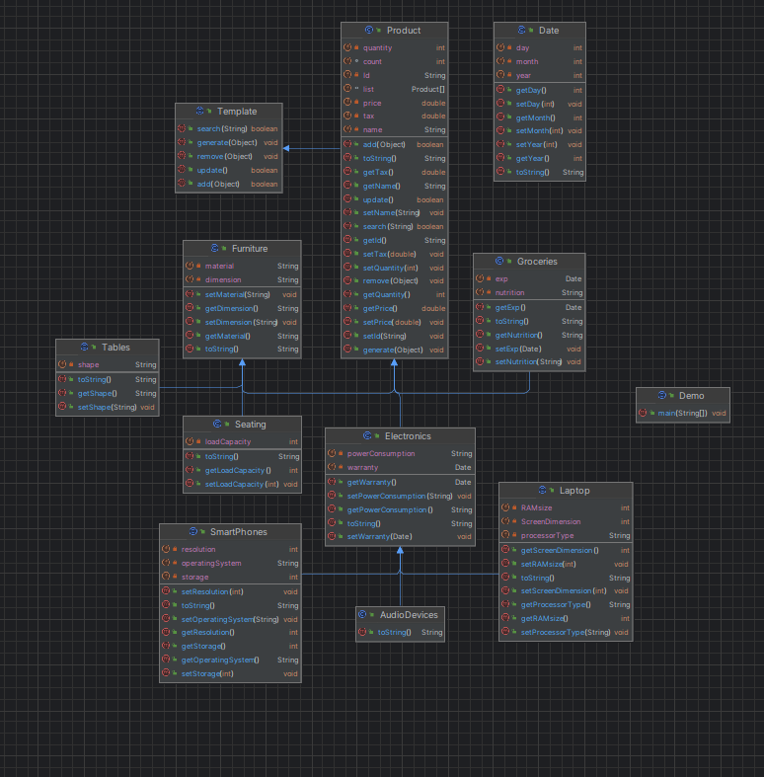







**Documentation:**

**Class Template:**

Class template is an abstract class. in this class, we declared our methods with their return types. We have defined these methods in our product class which inherits template class.

**Class Product:**

In this class, we have declared 5 variables, and we have defined five methods. Indeed, we have overridden the methods of our abstract class named template. This class is inherited by other classes which include: electronics, furniture, and groceries.

**Class Electronics:**

This class inherits product class and is inherited by other classes include: smartphones, laptops, and audio devices. This class inherits all the variables and methods of class product.

**Class Laptop:**

This class inherits electronic class which further inherits product class, so this type of inheritance is called multi-level inheritance. This class can access all the variables and methods of electronics class and product class.

**Class smartphones:**

This class inherits electronic class which further inherits product class, so this type of inheritance is called multi-level inheritance. This class can access all the variables and methods of electronics class and product class.

**Class Audio Devices:**

This class inherits electronic class which further inherits product class, so this type of inheritance is called multi level inheritance. This class can access all the variables and methods of electronics class and product class.

**Class furniture:**

This class inherits product class and is inherited by other classes which include: seating class, end tables class. This class inherits all the methods and variables of product class.

**Class Seating:**

This class inherits furniture class which further inherits product class, so this type of inheritance is called multi-level inheritance. Seating class can access all the variables and methods of furniture class and product class.

**Class Tables:**

This class inherits furniture class which further inherits product class, so this type of inheritance is called multi-level inheritance. Table class can access all the variables and methods of furniture class and product class.

**Class groceries:**

Class inherits product class and can access all variables and methods of product class.

**Class Date:**

This class is used in groceries class to make the expiry date variable of Date type. We have declared the variable of date type in groceries class to make it easier to show expiry date software various products.

**Class demo:**

This class contains the main method which runs the whole program. In this class we can create the objects of our classes like Laptop class, Smartphone class, Audio devices class, Seating class, tables class. Then we can use methods we have declared in our other classes like in product class.